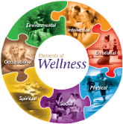**Name Quang Huynh Date 2/9/21**

 WELLNESS INVENTORY

**Instructions:** Below is a list of health and wellness indicators that describe how people feel and behave. The regular use of this inventory will increase your self-awareness.

**Rate how much these indicators described you today Very Moderately Hardly None**



1. How alert and clear headed, did you feel today?

2. How rested did you feel when you woke up this morning?



3. How energetic, ready to go did you feel today?

4. How strong did you feel today?



5. Were you able to get around well enough today?



6. Were you able to meet challenges in your life today?



7. How happy did you feel today?

8. How much were you able to put things in perspective?



9. Were you able to maintain your sense of humor today?

10. How often did you lose it today, explosive/outbursts?



11. Were you interesting to be with today?

12. How stressful was your day?



13. How much were you able to manage stresses today?

14. How stressful was your school day?



15. How much were you able to fulfill your school responsibilities? ______ ______ ______ ______



16. How well did you get along with other students today?

17. How much did you enjoy your family life today?



**Rate how much these indicators described you today Very Moderately Hardly None**

18. How rewarding was your family life today?



19. How much were you able to fulfill your family responsibilities?



20. How well did you get along with your friend(s) today?

21. How much were you able to meet your social obligations?



22. How much did you enjoy your social activities today?

23. How much time did you study today?



24. How confident did you feel today?



25. Did you feel good about your body today?

26. How much were you able to stay on task today



27. How well could you trust your instincts today?

28. How well could you trust your senses today?



29. Did you have any health symptoms that bothered you today?



30. Did you feel susceptible (likely to catch) to illness?

31. What was most stressful part of your day? School

32. How did you deal with that stressor? I just took some deep breaths and encouraged myself to continue.

33. Did your action make the stress better, worse, or no difference? A little better

34. What was the hardest part of your day? School

35. Looking at your response to #34, What did you do about it? Nothing, I just went on about doing my schoolwork.

36. How much time did you take for yourself today? I took about 11 hours for myself today.

37. Did taking time for yourself make your day better or worse? It felt the same.

38. What did you have to look forward to today? I looked forward to talking to my friends over the phone.

39. How did you feel at the end of the day? I felt very content and satisfied.

40. For what did you have to be thankful today? I was thankful for being able to spend time with such amazing people.

41. Did you have any trouble with your appetite today? No, I did not believe so.

42. How many meals did you eat today? I ate 6 meals today.

43. Was that normal for you? Yes, that is normal for me.

44. Were the meals well balanced? I think they were well-balanced.

45. How often did you snack today? I snacked around 5 times today.

46. Were they healthy snacks? Yes, I had fruits and chips.

47. How much water did you drink today? I drank around 5 bottles of water

48. How many servings of caffeine drinks did you have today? (1 serving 6-8 oz coffee or tea; 8-12 oz soda) 0

49. Did you take any medication or drugs today? No

50. Did you consult a health or mental health Practitioner today? No

51. What physical activity did you do today and how much time did you spend doing it? I rode my bike around my community and I spent around an hour doing that.

53. I went to sleep at 2 am/pm I woke up at 9 am/pm

54. Do you think you get enough sleep? Explain. I believe so, I feel somewhat rested.

**WARNING**

A high number of “Hardly” or “None” answers on this inventory could indicate the presence of serious physical and/or mental health conditions and should be immediately brought to the attention of a qualified physician, therapist or other appropriate professional



**Name Quang Huynh Due Date _________________**

WELLNESS EVALUATION

Answer the following questions, after you have completed the Wellness Inventory.

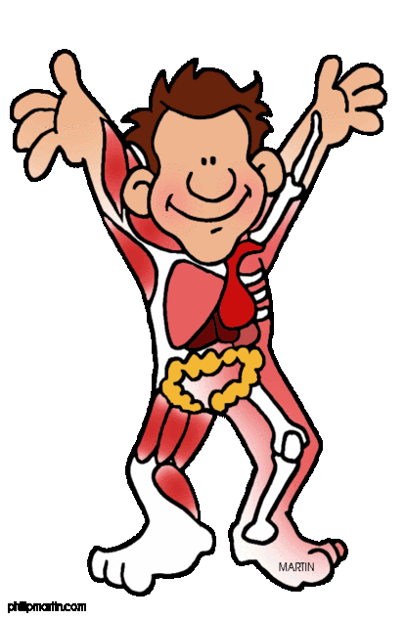

1. List five things that you do to keep your body healthy.
2. Every time I go down or up the stairs, I do 3-5 pullups.
3. Every hour, I do 5 pushups while gaming.
4. I go outside daily.
5. I ride my bike.
6. I eat fruits and drink a bunch of water.



1. List five things that you do to keep your mind healthy.
2. I am mentally active.
3. I better myself
4. I exercise frequently.
5. I talk to my friends and maintain my relationships.
6. I try to be as nice as possible to everyone I meet.



1. List five things that you do to keep your relationships healthy.
2. I talk to my friends daily.
3. I enjoy doing online activities with friends.
4. Cracking jokes
5. I help them when they need it, vice versa.
6. Be friendly.
7. Do you have a balance on your personal health triangle? I think so.

Give at least two reasons for your answer.

1. I feel like I get enough exercise and a well-balanced diet.

2. My mental state is okay, and my social life is alright too.

1. **What aspect of your health would you like to change?** Why do you want to make that change? I would like to change my diet to be more healthy. I want to make that change since I do eat a bunch of junk food, and eating healthy would feel nice.
2. **How might changing some of your behaviors make you happier and healthier?** Changing some of my behaviors would make me happier and healthier since I would better myself and I would feel confident. s